Code 1:

Code 2:

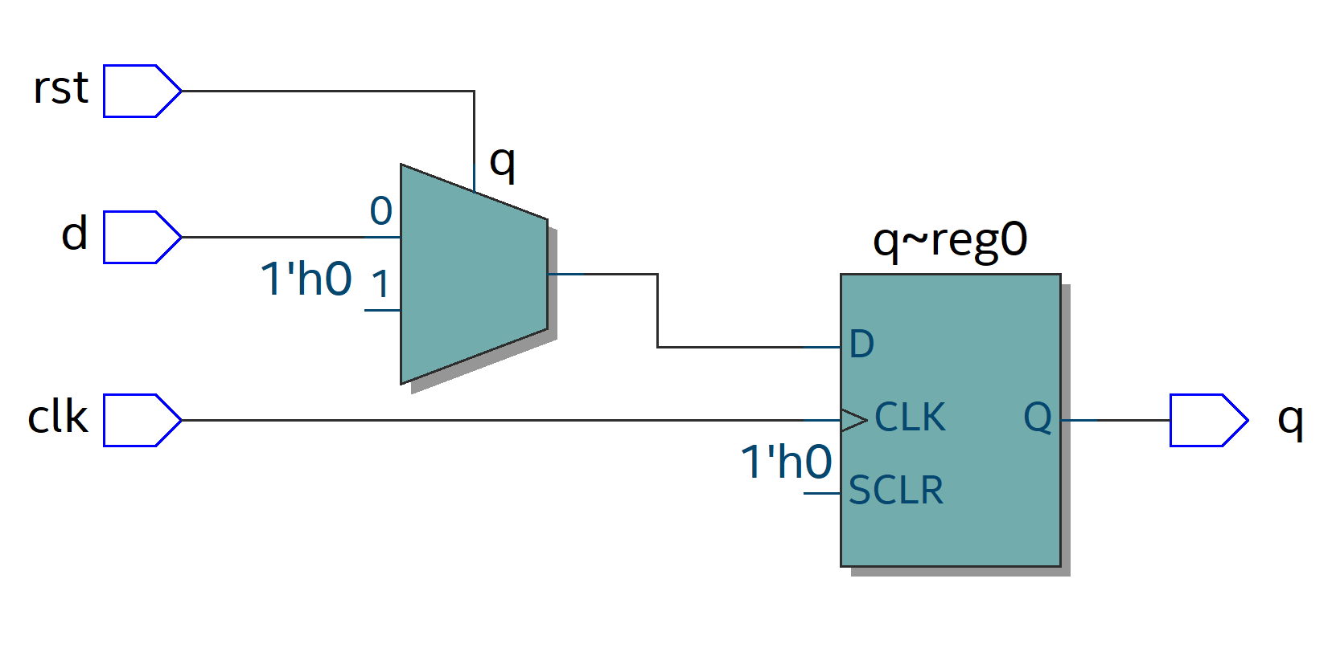

Code 3:

Step 3:

Part 2:



radix hexadecimal  
force clock_in 0 0 ns, 1 {20 ns} -r 40 ns   
run 8000 ns

Need vhdl code